I can…
Descubre 2, Lección preliminar
 | What are you talking about? | Understand, but still need help. | I´m a MASTER at this.
- Understand the uses of SER and how to us it. _________ __________ __________
- Understand the uses of ESTAR and how to
use it _________ __________ __________
- Understand how to use SER and ESTAR in
context _________ _________ __________
- Understand nouns and the articles that are
associated with them (el, la, los, las) __________ _________ __________
- Understand noun and adjective agreement __________ _________ __________
- Use possessive adjectives in place of an article
(mi, tu, su, nuestro) __________ __________ __________
- Conjugate regular verbs in the Present Tense
and I´m able to recognize them in context.
AR verb __________ __________ __________
ER verbs __________ __________ __________
IR verbs __________ __________ __________
- Conjugate the verb TENER in the present tense __________ __________ __________
- Know common TENER expressions
(tener calor, tener razón, tener que) __________ __________ __________
- Conjugate the verb IR in the present tense __________ __________ __________
- Use the verb IR to state activities that
a subject is going to do __________ __________ __________
- Conjugate verbs that change in the stem in
the present tense (e- ie, e- i, o-ue) __________ __________ __________
- Understand the concept of the Preterite tense
to talk about actions that already happened __________ __________ __________
- Conjugate –AR, -ER, and –IR verbs in the Preterite__________ __________ __________
- Conjugate –AR verbs that are irregular in the
Preterite tense for YO (car, gar, zar) __________ __________ __________
- Conjugate the verbs SER and IR in the Preterite __________ __________ __________
- Use the verbs SER and IR in the Preterite tense
appropriately __________ __________ __________
- Identify verbs that are irregular in the Preterite __________ __________ __________
- Understand the different meanings that verbs
take from the Present to the Past __________ __________ __________
- Understand what a direct object pronoun is
and how to use it in context __________ __________ __________
- Understand what an indirect object pronoun
is and how to use it in context __________ __________ __________
- Use an indirect object pronoun and a
direct object pronoun together __________ __________ __________
- Understand how to use the verb GUSTAR __________ __________ __________
- Understand other verbs that conjugate like
GUSTAR (aburir, faltar, importar, fascinar) __________ __________ __________

- Repaso del vocabulario
Yo |  | Tú
Él |  | Élla
Usted / Ustedes |  | Nosotros / nosotras
El chico |  | La chica
El hombre |  | La mujer
El / la estudiante |  | El / la profesor(a)
La madre |  | El padre
El / la hermano /-a |  | El padrastro
La madrastra |  | El / la tío /-a
El / la primo /-a |  | El / la abuelo /-a
El / la bisabuelo /-a |  | El / la jugador(a)
El / la empleado /-a |  | El / la entrenador(a)
El / la amigo /-a |  | El / la compañero /-a
La clase |  | La computadora
El lápiz |  | El bolígrafo  La pluma
La pizarra |  | La ventana
La puerta |  | La lámpara
La pared |  | El reloj
La bandera |  | La escuela
El escritorio |  | El pupitre
El sacapuntas |  | La basura
El coche / El auto |  | Bien
Bueno/ -a |  | Feliz
Emocionado |  | Triste
Gordo/- a |  | Delgado /-a
Torpe |  | Gracioso/-a
Cómico/-a |  | Mal/ Malo
Limpio/-a |  | Sucio/-a
Contento |  | Preocupado /-a
Alto/-a |  | Bajo/-a
Moreno /-a |  | Rubio /-a
Pelirrojo /-a |  | Canoso /-a
Calvo /-a |  | Fácil
Difícil |  | Importante
Práctico/-a |  | Divertido /-a
Aburrido /-a |  | Fascinante
Bonito/ -a |  | Feo /-a
Guapo /-a |  | Hermoso /-a
Inteligente |  | Trabajador (a)
Perezoso /-a |  | Artístico /-a
Encima de |  | Debajo de
Al lado de |  | Enfrente de
Detrás de |  | Sobre de
A la derecha de |  | A la izquierda de
¿Qué? |  | ¿Quién? ¿Quiénes?
¿Cómo? |  | ¿Dónde?
¿Adónde? |  | ¿De dónde?
¿Cuál? |  | ¿Por qué?
¿Cuándo? |  | ¿Con quién?
Hay |  | El / La / Los / Las
Un / Una |  | Unos / Unas
Ser |  | Estar
Ir |  | Tener
Hablar |  | Trabajar
Escuchar |  | Estudiar
Comer |  | Beber
Escribir |  | Compartir
Venir |  | tener calor
Tener …años |  | Tener frío
Tener ganas de |  | Tener hambre
Tener sed |  | Tener prisa
Tener razón |  | Tener que…
Poder |  | Poner
Comenzar / empezar |  | Hacer
Oír |  | Jugar
Repetir |  | Volver
Pedir |  | Salir
Traer |  | Dormir
Cerrar |  | Pensar
Perder |  | Preferir
Entender |  | Querer
Almorzar |  | Contar
Encontrar |  | Buscar
Mostrar |  | Recordar
Comprar |  | Vender
Llegar |  | Creer
Leer |  | Ver
Mirar |  | Saber
Conocer |  | Conducir
Decir |  | Preguntar
Dar |  | Anoche
Ayer |  | Anteayer
El año pasado |  | Aburrir
Faltar |  | Importar
Molestar |  | Encantar
Fascinar |  | Quedar
La bolsa |  | La ropa
La camiseta |  | La camisa
Los pantalones (cortos) |  | Los zapatos
Los calcetines |  | El sombrero
El vestido |  | La falda

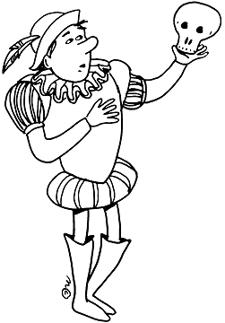
- El verbo SER
The verb SER is an action verb. state of being verb.
When do we use the verb SER?
D _________________________ Hoy es lunes.
O _________________________ Yo soy profesora.
C _________________________ Marco es alto y guapo.
T _________________________ Es la una y media.
O _________________________ Sra. Brown es de Panamá.
R _________________________ Ellos son amigos.
Práctica 1: Completar Abre tu texto a página 2 y haz actividad 1. Escribe tus repuestas abajo.

- ______________________________
- ______________________________
- ______________________________
- ______________________________
- ______________________________

- El verbo ESTAR
The verb ESTAR is an action verb. state of being verb.
When do we use the verb ESTAR?
P ___________________________ Estoy estudiando.
L ___________________________ Los estudiantes están en la clase.
A ___________________________ Mi dormitorio está ordenado.
C ___________________________ Luisa está enferma hoy.
E ___________________________ Pedro está enamorado con Marta.
Práctica 1: El primer día de clases. Abre tu texto a página 2 y haz actividad 2. Escribe tus repuestas abajo.

- _____________________________
- _____________________________
- _____________________________
- _____________________________
- _____________________________

- SER Versus ESTAR
Práctica 1: ¿Ser o estar? Abre tu texto a página 2 y haz actividad 3. Escribe tus respuestas abajo.

- _______________________
- _______________________
- _______________________
- _______________________
- _______________________
- _______________________
- _______________________
- _______________________
- _______________________

Práctica 2: Fill in the blanks of the following conversation with the appropriate form of SER or ESTAR.
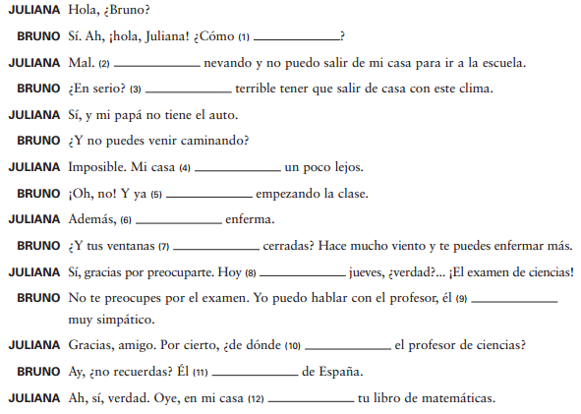

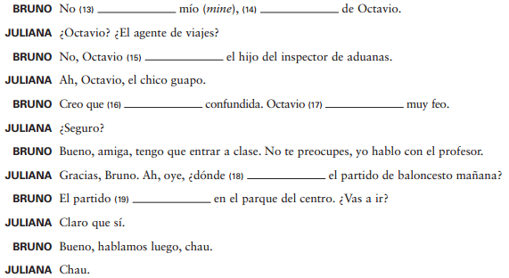
Práctica 3: (Audio from Descubre 1, Lección 5, Estructura 5.3 Audio Activities)
- 1: Escoger You will hear some questions with a beep in place of the verb. Decide which form of Ser or Estar should complete each question and circle it.

- es está
- son están
- es está
- es está
- es está
- es está

- 4: ¿Lógico o no? You will hear some statements. Decide if they are lógico or ilógico.

- Lógico Ilógico
- Lógico Ilógico
- Lógico Ilógico
- Lógico Ilógico
- Lógico Ilógico
- Lógico Ilógico

- Articles
Articles are used to help identify nouns. They are placed ______________ of the noun that they modify and help to identify the ____________________ (masculine or feminine) and ___________________ (singular or plural) of the noun.
 | Definite Articles | Indefinite Articles
Masc. /S | ___________ libro  The book | ____________ libro  A book
Fem. / S | ____________ mochila  The bookbag | ____________ mochila  A bookbag
Masc. /P | ____________ libros  The books | ____________ libros  Some books
Fem. / P | ____________ mochilas  The book bags | ____________ mochilas  Some book bags
Práctica 1: Add the appropriate definite or indefinite article for each noun.
Definidos | Indefinidos
- _________ comunidad | 6)__________ lápiz
- _________ pintores | 7)__________ pasajeros
- _________ programa | 8)__________ computadoras
- _________ natación | 9)__________ traje de baño
- _________ revistas | 10)_________ lección
Práctica 2: (Audio from Descubre 1, Lección 1, Estructura 1.1 Identificar) You will hear a series of words. Identify if each of the words is either masculine or feminine.

- Masculine Feminine
- Masculine Feminine
- Masculine Feminine
- Masculine Feminine
- Masculine Feminine
- Masculine Feminine
- Masculine Feminine
- Masculine Feminine

- Noun and Adjective Agreement
In Spanish, nouns and adjectives MUST agree in the same ____________________ and _____________________.
Práctica 1: Complete each sentence with the appropriate adjective. Change the form of the adjective as necessary for gender/number agreement.
Antipático Interesante Mexicano
Difícil Joven Moreno
- Mi tía es _______________________________________. Vive en Guadalajara.
- Mi primo no es rubio, es _________________________________.
- Mi amigo cree que la clase no es fácil, es __________________________________.
- Los libros son _____________________________. Me gustan mucho.
- Mis hermanos son ______________________________. No tienen muchos amigos.
- Las gemelas tienen nueve años. Son ______________________________________.
- Possessive Adjectives
These take the place of an article and must modify the noun with the same number and gender.
My cousin : ____________ primo  My cousins : ____________ primos | Our father : _______________ padre  Our mother : _______________ madre  Our uncles : _______________ tíos  Our aunts : _______________ tías
Your book : ____________ libro
Your books : ____________ libros
His class : ____________ clase  Her class : ____________ clase  Your (formal) class : ______________ clase | Their class : _____________ clase  Your (plural) class : _____________ clase
“SU” can be used in a wide variety of ways. Just make sure that you modify the possessive adjective if the noun is plural.
Su perro (His dog) : Sus perros (His dogs)
Práctica 1: Turn to page 3 of your textbook and write the answers to Actividad 7 below.

- ________________
- ________________
- ________________
- ________________
- ________________
- ________________
- ________________
- ________________
Práctica 2: Rewrite the following phrases using a possessive adjective.
- Es el texto de Marta. ____Es su texto ____________________
- Son los tíos de Luisa. _________________________________
- Es la casa de nosotros. _________________________________
- Es el padre de yo. _________________________________
- Son los zapatos de Ud. _________________________________
- Es la computadora de él. _________________________________
- Son las flores de nosotros. _________________________________
- Son los videos de ellos. _________________________________
Práctica 3: (Audio from Descubre 1, Lección 3, Estructura 3.2, Identificar) Listen to each statment and indicate the possessive adjective that you hear.
 | My | Your (fam) | Your (form) | His / Her | Our | Their

- Regular Verbs in the Present Tense
When we conjugate a verb in Spanish in the Present Tense it can be translated in three different ways.
I swim
Yo nado: I am swimming
I do swim

What does it mean when we “conjugate” a verb?
- Conjugation is the process of __________________________ a verb according to the ____________________________ (the noun performing the action) of the sentence.
How do we conjugate a Regular Verb in the Present Tense?
Step 1: Identify the subject Step 2: Chop off the ending Step 3: Add the most appropriate ending
Subject Pronoun | Hablar | Comer | Escribir
Yo
Tú
Él
Ella
Usted
Nosotros
Nosotras
Vosotros
Vosotras
Ellos
Ellas
Ustedes

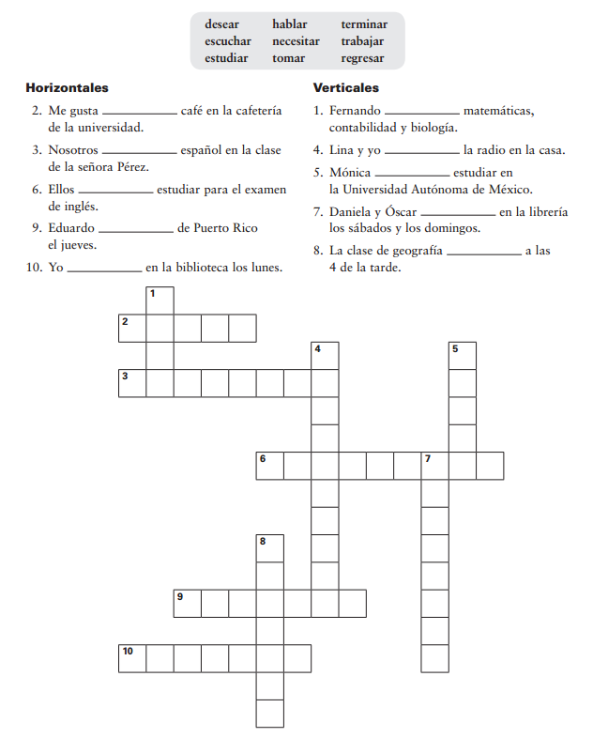
Práctica 1: Crucigrama con los verbos de –AR

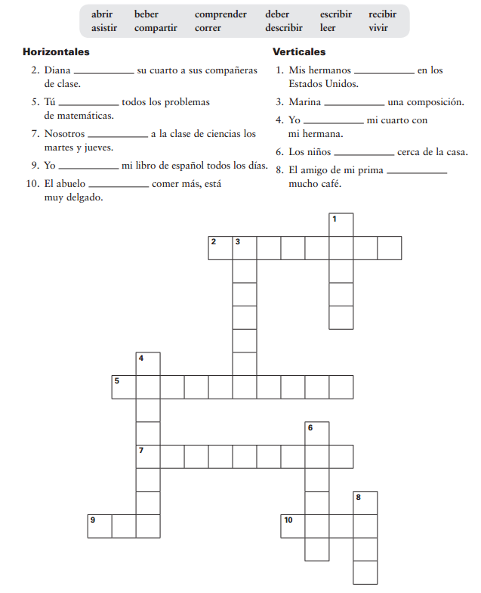
Práctica 2: Crucigrama con los verbos de –ER y –IR

Práctica 3: Completar (página 4 del texto) Putting it all together. Turn to page 4 of your textbook and write your answers to activity 1 on the lines below.

- ______________________________
- ______________________________
- ______________________________
- ______________________________
- ______________________________
- ______________________________
- ______________________________
- ______________________________
- ______________________________
- ______________________________
- ______________________________
- ______________________________

- Irregular Verbs and Boot Verbs
El verbo TENER
- The verb TENER means ______________________ and is an irregular verb.
However it can also take on other meanings.
          - Tener … años : _______________________
          - Tener calor : _______________________
          - Tener frío : _______________________
          - Tener ganas de : ______________________
          - Tener hambre : _______________________
          - Tener prisa : _______________________
          - Tener razón : _______________________
          - Tener sed : _______________________
          - Tener que … : _______________________
Práctica 1: Abre el texto a página 4 y haz actividad 2. Escribe tus repuestas abajo.

- __________________________
- __________________________
- __________________________
- __________________________
- __________________________
- __________________________

Práctica 2: (Audio from Descubre 1, Lección 3, Estrucura 3.4) Listen to each situation and choose the appropriate Tener expression. Each situation will be repeated.
- Tienes sueño. Tienes prisa.
- Tienen mucho cuidado. Tienen hambre.
- Tenemos mucho calor. Tenemos mucho frío.
- Tengo sed. Tengo hambre.
- Ella tiene razón. Ella no tiene razón.
- Tengo miedo. Tengo sueño.
El verbo IR
- The verb IR translates to ________________________________.

Ejemplos with “A”.
- Yo voy _____________ escuela. I am going to school.
- Tú vas _____________ café. You are going to the café.
- Nostros vamos ______________ montañas. We are going to the mountains.
Immediate Future Tense
- Pedro va ___________ estudiar. Pedro is going to study.
Práctica 1: Abre el texto a página 5 y haz actividad 3. Escribe las repuestas abajo.

- _________________________
- _________________________
- _________________________
- _________________________
- _________________________
- _________________________
- _________________________
- _________________________

BOOT Verbs
- These verbs will change in the root for the following subjects. Yo, Tú, Él/Ella/ Ud., and Ustedes forms. Take a look at the following examples.
Dormir (o – ue)
Pedir (e - i)

Jugar (u – ue)
Preferir (e – ie)

Práctica: Abre tu texto y completa las siguientes actividades de página 5 - 7. Escribe las repuestas abajo.
Actividad 5: Oraciones
- _______________________________________________________________________
- _______________________________________________________________________
- _______________________________________________________________________
- _______________________________________________________________________
Actividad 6: Conversación

- ______________________________
- ______________________________
- ______________________________
- ______________________________
- ______________________________
- ______________________________
- ______________________________
- ______________________________
- ______________________________

Actividad 7 : Un día típico

- ______________________________
- ______________________________
- ______________________________
- ______________________________
- ______________________________
- ______________________________
- ______________________________
- ______________________________
- ______________________________
- ______________________________

Actividad 9 : Contestar Answer the questions from the textbook below and be prepared to discuss in class.
Complete sentence?
- _____________________________________________________ Sí No
- _____________________________________________________ Sí No
- _____________________________________________________ Sí No
- _____________________________________________________ Sí No
- _____________________________________________________ Sí No
- _____________________________________________________ Sí No
- _____________________________________________________ Sí No
- _____________________________________________________ Sí No
- _____________________________________________________ Sí No
- _____________________________________________________ Sí No

- El pretérito
- What is the Preterite tense?

- What are some words that help to identify that the Preterite tense?

How do we conjugate verbs in the Preterite Tense?
Regular Verbs
 | Hablar | Comer | Escribir
Yo | I spoke | I ate | I wrote
Tú | You spoke | You ate | You wrote
Él / Ella | He / She spoke | He / She ate | He / She wrote
Usted (Ud.) | You (fm) spoke | You (fm) ate | You (fm) wrote
Nosotros | We spoke | We ate | We wrote
Ellos / Ellas | They spoke | They ate | They wrote
Ustedes (Uds.) | You all spoke | You all ate | You all wrote
Ejemplo
Mis amigos y yo vimos una película anoche.
My friends and I saw a movie last night.
-ER and –IR verbs have the same endings in the Preterite!

Don’t forget about the CAR, GAR, ZAR verbs!!
  - These verbs are irregular in the _______________________ of the Preterite tense for verbs that end in –CAR, -GAR, and –ZAR.
  - The reason why we change the verb is to hold onto the original sound of the verb.
Ejemplos

Buscar Yo bus_______ Pagar Yo pa_______ Almorzar Yo almor______

“I” to “Y”s
  - These verbs will change from an _____________ to a ________________ in the “él, ella, usted” and the “ellos, ellas, ustedes” forms.
  - It does this to break up the vowels.
Other “I” to “Y” verbs are:
Creer
Oír
Leer
Yo | Nosotros
Tú
Él | Ellos

Más información
- -AR and –ER verbs that stem change in the present (also known as _________________ verbs) ____________________________ stem change in the preterite.
- The verb “ver” (which translates as “_________________________”) _____________________________ have accent marks in the preterite.
Práctica 1: Abre el texto a página 10 y haz actividad 1. Escribe las respuestas abajo.

- ___________________________
- ___________________________
- ___________________________
- ___________________________
- ___________________________
- ___________________________
- ___________________________
- ___________________________
- ___________________________
- ___________________________

Práctica 2: Conjugate the following verbs in the parenthesis. Take note! These are –CAR, -GAR, and –ZAR verbs!
1) Mis amigos __________________________ (pagar) treinta dólares por las faldas.
2) Yo ___________________________ (pagar) veinte. Encontré una ganga.
3) ¿Qué prendas_________________________ (buscar) tú en el almacén?
4) Yo _______________________ (buscar) un traje nuevo.
5) Ella ___________________________ (almorzar) en la cafetería.
6) Yo ___________________________ (almorzar) en el patio.
7) El lunes pasado nosotros _______________________ (jugar) al baloncesto.
8) Ayer yo ____________________________ (jugar) al fútbol.
Práctica 3: Abre el texto a página 10 y haz actividad 2. Escribe las repuestas abajo.

- ___________________________
- ___________________________
- ___________________________
- ___________________________
- ___________________________
- ___________________________
- ___________________________
- ___________________________
- ___________________________

Irregular Verbs in the Preterite Tense
- Ser versus IR
  - Both of these verbs have the same conjugation in the preterite tense therefore we must look for context clues to help us determine which verb it is.
  - EX
    - Yo fui al supermercado. I went to the market.
    - Fue a él quien yo vi ayer. It was him that I saw yesterday.
 | Ser: ______________ | Ir: _______________
Yo fui
Tú fuiste
Él fue
Nosotros fuimos
Ellos fueron
Práctica 1 Completa estas conversaciones con la forma correcta del pretérito de ser o ir. Indica el infinitivo de cada forma verbal.
Conversación 1
Raúl: ¿Adónde (1) _____________________ ustedes de vacaciones.  Pilar: (2) ______________________ a Perú.  Raúl: ¿Cómo (3) __________________________ el viaje?  Pilar: ¡(4) __________________________ estupendo! Machu Picchu es increíble.  Raúl: ¿(5) __________________________ car el viaje?  Pilar: No, el precio (6) ______________________ muy bajo. Sólo  costó tres mil dólares. | Ser Ir  Ser Ir  Ser Ir  Ser Ir  Ser Ir  Ser Ir
Conversación 2
Isabel: Tina y Vincente (7) _____________________ novios, ¿no?  Lucía: Sí, pero ahora no. Anoche Tina (8) ____________________ a  comer con Gregorio y la semana pasada ellos  (9) _________________ al partido de fútbol.  Isabel: ¿Ah sí? Javier y yo (10) ________________ al partido y no los  vimos. | Ser Ir  Ser Ir  Ser Ir  Ser Ir

Más irregulares
The following verbs are irregular in all forms. If you can remember the “Yo” forms the remaining forms will all be similar.
Hacer for the él form is hizo
Infinitive | Yo form | Endings for the majority of these verbs.  -e, -iste, -o, -imos,  -isteis, -ieron
__________________ | Hice
__________________ | Quise
__________________ | Vine
__________________ | Pude
__________________ | Supe
__________________ | Puse | Endings for verbs with the * symbol  -e, -iste, -o, -imos,  -isteis, -eron
__________________ | Dije *
__________________ | Traje *
__________________ | Conduje *
__________________ | Tuve
__________________ | Estuve
__________________ | Anduve

Dar is just wierd : Yo di, Tú diste, Él dio, Nosotros dimos, Ellos dieron
Haber (hay) in the Preterite is Hubo

Práctica 1: Completa estas oraciones con el pretérito de los verbos entre paréntesis.
- El sábado ___________________________ (haber) una fiesta sorpresa para Elsa en mi casa.
- Sofía ___________________ (hacer) un pastel para la fiesta y Miguel _______________ (traer) un flan.
- Los amigos y parientes de Elsa _____________________ (venir) y ________________________ (trajer)regalos.
- El hermano de Elsa no _________________________ (venir) porque _______________________ (tener) que trabajar.
- Su tía María Dolores tampoco _______________________ (poder) venir.
- Cuando Elsa abrió la puerta, todos gritaron: “¡Feliz cumpleaños!” y su esposo le _______________ (dar) un beso.
- Elsa no ________________________ (saber) cómo reaccionar (to react). ________________________ (estar) un poco nerviosa al principio, pero pronto sus amigos _________________________ (poner) música y ella _____________________ (poder) relajarse bailando con su esposo.
- Al final de la noche, todos __________________________ (decir) que se divirtieron mucho.
Práctica 2: Abre el texto a página 11 y haz actividad 6. Escibe las respuestas abajo.

- ______________________________
- ______________________________
- ______________________________
- ______________________________
- ______________________________
- ______________________________
- ______________________________
- ______________________________
- ______________________________
- ______________________________

Práctica 3: Form complete sentences using the information provided on page 11, activity 7 of the textbook in the correct order. Use the preterite tense of the verbs.
- ________________________________________________________________________
- ________________________________________________________________________
- ________________________________________________________________________
- ________________________________________________________________________
Práctica 4: Lee un correo electrónico a Bárbara de Marieta i escribe el verbo más apropiado para completar el mensaje. . Si necesitas ayuda, mira en página 11 del texto.
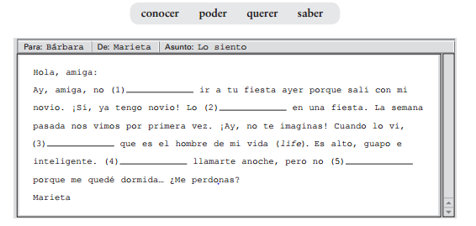
Práctica 5: Continua a actividad 9 on page 12 of the textbook y escribe las respuestas abajo.
- _____________________________ Why? _____________________________
- _____________________________ Why? _____________________________
- _____________________________ Why? _____________________________
- _____________________________ Why? _____________________________
- _____________________________ Why? _____________________________
- _____________________________ Why? _____________________________
- _____________________________ Why? _____________________________
- _____________________________ Why? _____________________________
- _____________________________ Why? _____________________________
- _____________________________ Why? _____________________________

Una competición Con un compañero de clase túrnense en traducir dos verbos a español para conectarlos. El objeto del partido es crear un cuadro. La persona con más cuadros que otro ganará.

I sang | We ran | John wrote | You drove | They studied | I paid
He made | Pilar said | They read | You (formal) returned | I practiced | You wanted
Luis met | She was able | You placed | I made | I searched for | We believed
You ran | We ate | They practiced | They Heard | I watched | He listened
We watched | You brought | He came | I ate lunch | They found out | They told

Práctica: (Audio from Descubre 1, Lección 9, Estructura 9.1, Activity 4) Listen to the dialogue and write the missing words.
(1)___________________________ por un amigo que los Márquez (2)_________________________ a visitar a su hija. Me (3) _______________________________ que (4)______________________________ desde Antofagasta y que se (5)___________________________________ en el Hotel Carrera. Les (6)__________________________ una llamada anoche, pero no (7) _____________________________ el teléfono. Sólo (8)____________________________ dejarles un mensaje. Hoy ellos me (9)______________________________ y me (10)_______________________________ si mi esposa y yo teníamos tiempo para almorzar con ellos. Claro que les (11)_____________________________qué sí.

- Direct Object Pronouns
- In your own words, what is a Direct Object?

- Find the direct object in the following sentences and underline it.
- Ayer yo leí un libro.
- Mis amigos fueron a ver una película.
- El perro comió su comida rápidamente.
- We can then use a pronoun to take the place of the direct object. These pronouns will then go ___________________________ of the conjugated verb OR ____________________________ to an infinitive or gerund if there is one.
Ejemplos
Ayer yo leí un libro. Ayer yo lo leí.
Mis amigos fueron a ver una película. Mis amigos la fueron a ver.
Mis amigos fueron a verla.
(If you attach the direct object pronoun to a gerund be sure to add an accent mark)
Práctica: Remember, direct object pronouns go in front of the verb. Try it!
- I help them (chicos y chicas) : _________ _________________________
- I call her. : _________ _________________________
- I see you. : _________ _________________________
- I have it. (homework) : _________ _________________________
- We call him. : _________ _________________________
- They call me. : _________ _________________________
Now let´s try it with the preterite.
- I found them. (the books) : _________ _________________________
- He called you. : _________ _________________________
- We talked to you. (Ud.) : _________ _________________________
- I ate it (spaghetti) : _________ _________________________
- We saw it (movie) : _________ _________________________
- I paid for it (blouse) : _________ _________________________
Now let´s try it with compound verb phrases.
- We can see it (the fountain) _______ ____________________ ____________
____________________ ____________________
- I want to call her _______ ____________________ ____________
____________________ ____________________
- I want to eat it (chocolate) _______ ____________________ ____________
____________________ ____________________
- We should buy them (shoes) _______ ____________________ ____________
____________________ ____________________
- You are reading it (magazine)_______ ____________________ ____________
_____________________ ____________________
- I have to do it (homework) ________ ____________________ ____________
_____________________ ____________________
- Bob is watching me ________ ____________________ ____________
_____________________ ____________________
- I was able to buy them ________ ____________________ ____________
_____________________ ____________________

- Indirect Object Pronouns
An indirect object pronoun identifies __________________________ or _____________________ an action is done.
To find out the indirect object of a sentence, put the original sentence into a question. For example:
    - Yo leo el libro a Annabelle. Who am I reading the book to?
Annabelle : she is the indirect object
Original sentence: My parents always buy ice cream for my brother and me.
Now, circle the DOP: My parents always buy it for my brother and me.
Now, circle the DOP, underline the IOP: My parents always buy it for us.
Here are the Indirect Object Pronouns in Spanish
= (to / for) me | = (to / for) us
= (to / for) you | = (to / for) you all
= (to / for) him, her  you forml | = (to / for) them,  you formal
Repasa
- An indirect object answers the question __________________________________.
- In Spanish, you´ll often see the words ____________________________________.
- Remember, direct objects are the receiver of the action (verb). Indirect Objects are the receiver of ________________________________, both real (like a present or ball) and abstract (like permission).
Circle the indirect objects (they receive the direct object) and write the IOPs that would replace them. Then, write the IOP again in the Spanish translation. Note that it goes in front of the verb.
1. I buy the present for my grandma. __________ Yo ______ compro el regalo.
2. She buys the shirt for her son. __________ Ella ________ compra la camisa.
3. I buy the chocolates for you. __________ Yo _________ compro los chocolates.
4. I bring the lunch for them. __________ Yo _________ traigo el almuerzo.
5. Carlos gives the flowers to us. __________ Carlos _________ da las flores.
6. I make tacos for my family. __________ Yo _________ hago los tacos.
¿Dónde está el IOP? Just like with the DOPs, the indirect object pronoun goes infront of the conjugate verb.
In addition, since “le” has a wide variety of uses, it would be helpful to include the original indirect object phrase (ejemplo: a Marta or para usted)
- Indirect Object Pronouns WITH Direct Object Pronouns
When we use two pronouns together, just remember that the
___________________________ goes before the __________________________
These pronouns will be placed ________________________ the CONJUGATED verb or can be ______________________________ to an INFINITIVE
- LE LO is a NO GO: Whenever you have an IOP and a DOP that both start with the letter __________, it doesn´t sound great. Therefore we need to change the IOP into the word __________.

ORIGINAL SENTENCE | DIRECT OBJECT PRONOUN | DIRECT OBJECT AND INDIRECT PRONOUNS
Ellos compran los libros para mí. | Ellos _______ compran para mí. | Ellos ______ _______ compran.
Nosotros hacemos el almuerzo para él. | Nosotros ________ hacemos para él. | Nosotros _______ _________ hacemos.
Tú leíste el periódico a tu padre. | Tú ________ leíste a tu padre. | Tú _______ ___________ leíste.
Marta compró el vestido para Luisa. | Marta _________ compró para Luisa. | Marta _________ _________ compró.
El perro trajo un zapato mascado a mí. | El perro _______ trajo a mí. | El perro ________ __________ trajo.
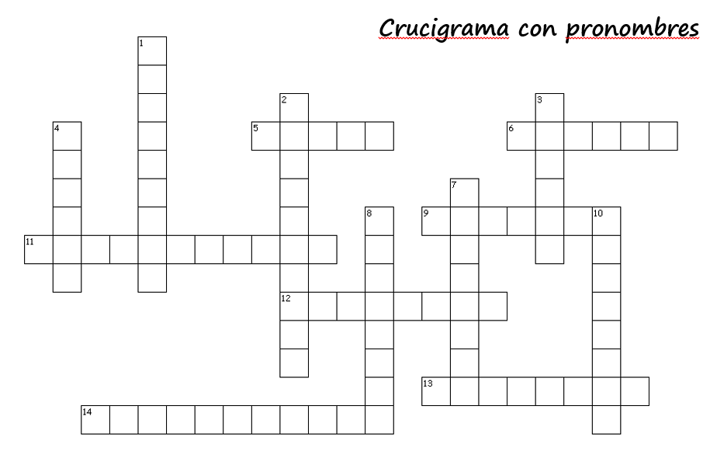

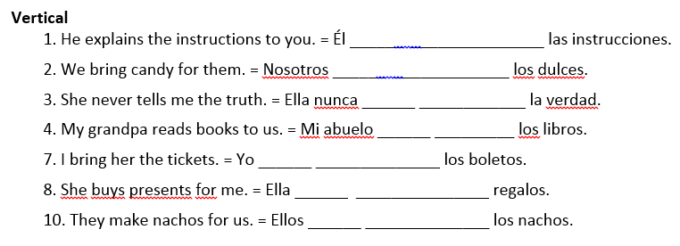
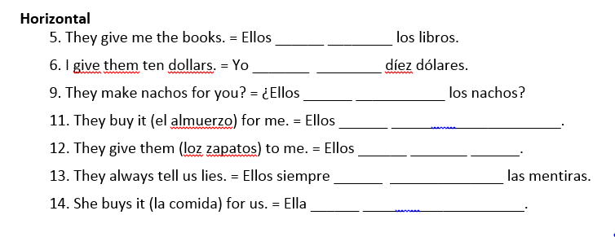

- Gustar and Similar Verbs
A mí, me gusta nadar. I like to swim.
A él, le gustan las papas fritas. He likes french fries.
However!! These are the literal translations of the above sentences.
________________________________________________
________________________________________________

These verbs are interesting because they conjugate based off of _________________________________ that is being liked (or annoying, or interesting, ect.) NOT the _________________________________.
Who is doing the liking |  | IOP | Verb | Thing being liked
A mí, | ______________
A tli, | ______________ |  | Singular
A él  A ella  A usted | ______________ |  | _________________ | El libro  Correr (verbs are sing.)
A nosotros | ______________ |  | Plural
A ellos  A ellas  A ustedes | _______________ |  | __________________ | Los perros  Las clases
Práctica 1 : Fill in the blanks with the most appropriate forms of the following verbs then translate.
- A ellos, __________ ______________________ (molestar) las películas románticas.
_____________________________________________________________________
- A mí, ___________ _______________________ (importar) aprender el español.
_____________________________________________________________________
- Los libros de Steinbeck _____________ __________________ (fascinar) a nosotros.
_____________________________________________________________________
- ¿Hacer ejercicios ____________ _______________________ (encantar) a ti?
_____________________________________________________________________
Práctica 2: Abre el texto a página 15 y haz actividad 4. Escribe las repuestas abajo.

- _________ _______________________
- _________ _______________________
- _________ _______________________
- _________ _______________________
- _________ _______________________
- _________ _______________________
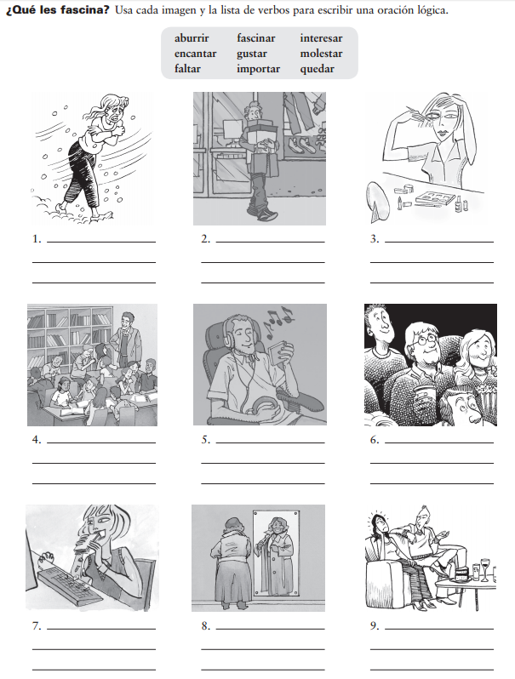
Práctica 3 : Usa cada imagen y la lista de verbos para escribir una oración lógica.
Mi madre
Yo
Nosotros
Pedro
Tú
Usted
Raquel
Pilar y Marcos
Marta

Práctica 4: (Audio from Descrubre 1, Lección 7 Estructura 4, Actividad 4) Listen to this conversastion. Then fill in the char with Eduardo´s preferences and answer the question that follows.
Le gusta | No le gusta

¿Qué van a hacer los chicos esta tarde? __________________________________________
Preguntas personales
Answer the following questions in complete sentences and be prepared to discuss as a class.
- ¿Cuántas horas duermes cada noche?
_____________________________________________________________________
- ¿Cuándo haces la tarea de matemáticas?
_____________________________________________________________________
- ¿Adónde sales con tus amigos los fines de semana?
_____________________________________________________________________
- ¿Prefieres ver películas en el cine o en casa?
_____________________________________________________________________
- Cuando ves películas en el cine, ¿con quién vas?
_____________________________________________________________________
- ¿A qué hora te acostaste hoy?
_____________________________________________________________________
- ¿Prefieres bañarte o ducharte?
_____________________________________________________________________
- ¿Te molesta la música cuando estudias?
_____________________________________________________________________
- ¿Adónde fuiste durante las vacaciones o te quedaste en casa?
_____________________________________________________________________
- ¿Crees que la clase de español va a ser fácil o difícil?
_____________________________________________________________________

